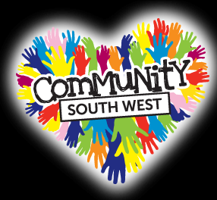
2015 Controlled Assessment
‘Community Spirit’

Folder 1: Activity 1

❑ Research Charities ____________
www.communitysouthwest.co.uk
❑ Research festivals/concerts ____________
❑ Logo ____________
❑ Strapline ____________
❑ Music database (Spreadsheet) ____________
❑ Audio clip script ____________
❑ Audio clip completed ____________
❑ Activity 1 review ____________
❑ Update Sources Table ____________

Folder 2: Activity 2

❑ ‘Community Spirit’ event model ____________
❑ Recommendations ____________
❑ Digital advert ____________
❑ Activity 2 review ____________
❑ Update Sources Table ____________

Folder 3: Activity 3

❑ Animated banner ____________
• Timeline storyboard ____________
• Finished animated banner ____________

E–newsletter ____________
• Storyboards ____________
• Finished e-newsletter (and assets) ____________

❑ Activity 3 review ____________
❑ Update Sources Table ____________

Folder 4: Activity 4

❑ Evaluation ____________

Folder 5: Development

❑ Sources table ____________

Student Name: __________________________________________________________

