Managing Working Capital
Read: What is working capital and put a one line summary here:

Read : The working capital cycle and draw the diagram here:

Read problems caused by insufficient working capital, draw a mind map to illustrate the key points here:

Problems caused by insufficient working capital

Read: The following section and answer the questions:
Different industries have different optimum working capital profiles, reflecting their methods of doing business and what they are selling.
• Businesses with a lot of cash sales and few credit sales should have minimal trade debtors. Supermarkets are good examples of such businesses;
• Businesses that exist to trade in completed products will only have finished goods in stock. Compare this with manufacturers who will also have to maintain stocks of raw materials and work-in-progress.
• Some finished goods, notably foodstuffs, have to be sold within a limited period because of their perishable nature.
• Larger companies may be able to use their bargaining strength as customers to obtain more favourable, extended credit terms from suppliers. By contrast, smaller companies, particularly those that have recently started trading (and do not have a track record of credit worthiness) may be required to pay their suppliers immediately.
• Some businesses will receive their monies at certain times of the year, although they may incur expenses throughout the year at a fairly consistent level. This is often known as “seasonality” of cash flow. For example, travel agents have peak sales in the weeks immediately following Christmas.
Working capital needs also fluctuate during the year
The amount of funds tied up in working capital would not typically be a constant figure throughout the year.
Only in the most unusual of businesses would there be a constant need for working capital funding. For most businesses there would be weekly fluctuations.
Many businesses operate in industries that have seasonal changes in demand. This means that sales, stocks, debtors, etc. would be at higher levels at some predictable times of the year than at others.

In principle, the working capital need can be separated into two parts:
• A fixed part, and
• A fluctuating part
The fixed part is probably defined in amount as the minimum working capital requirement for the year. It is widely advocated that the firm should be funded in the way shown in the diagram below:
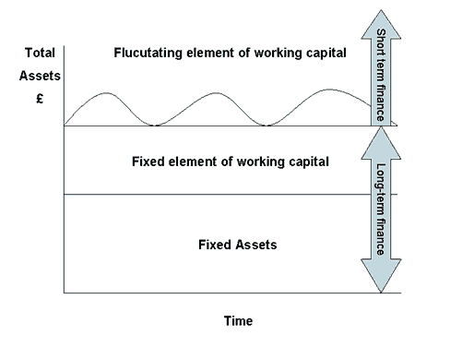
The more permanent needs (fixed assets and the fixed element of working capital) should be financed from fairly permanent sources (e.g. equity and loan stocks); the fluctuating element should be financed from a short-term source (e.g. a bank overdraft), which can be drawn on and repaid easily and at short notice.
- Name 4 reasons that working capital might fluctuate in a business

- What are the two parts of working capital and how should they be financed?

Draw the: Need for contingency Finance diagram here

Read: Can businesses have too much working capital, and How should a business manage its working capital, and Management of working capital. Now try the questions on page 133 (section A)
1
2
3
4
5
6
7
8
9
10

Now try B1 and B2

Land of Leather in administration
Consumers are spending less because of the economic downturn
Retailer Land of Leather has called in administrators after attempts to sell the firm and raise extra money failed.
The company said it had made every effort to cut costs but that market conditions remained tough and January sales had been "very disappointing".
Talks with potential bidders ended in December after it said the offers gave "insufficient value" for shareholders.
Land of Leather - which employs 850 people -issued three profit warnings in 2008 as sales slumped.
The Kent-based firm said it had appointed Lee Manning and Nick Edwards of Deloitte as joint administrators.
Customer protection
"The administrators are working closely with the management to protect the interests of customers who have paid deposits on furniture orders."
"We have taken a number of steps both to protect customers and to inform them of how the administration affects their circumstances."
All those who either paid a deposit by credit card or Visa debit card, or who have paid a deposit by any means since 26 December are fully protected, said Deloitte.
Meanwhile customers who paid a deposit by cash or by a non-Visa debit card before 26 December will be offered a discount on other stock if their original order cannot be fulfilled.
"However, it is the objective of the administrators to sell the business as a going concern and have all deposits honoured", added Deloitte.
Stores are open for business as usual, but Deloitte is urging customers who have paid deposits to use the sales hotline, email enquiry address and website, rather than to visit the stores, unless they aim to pay the balance on goods ready for delivery.
Consumers have been cutting their spending as a result of the economic slowdown, hitting sales of items such furniture.
Last week rival Sofa Workshop said it had started steps to appoint administrators.
Land of Leather has 109 stores in the UK and the Republic of Ireland.
Monday, 12 January 2009

